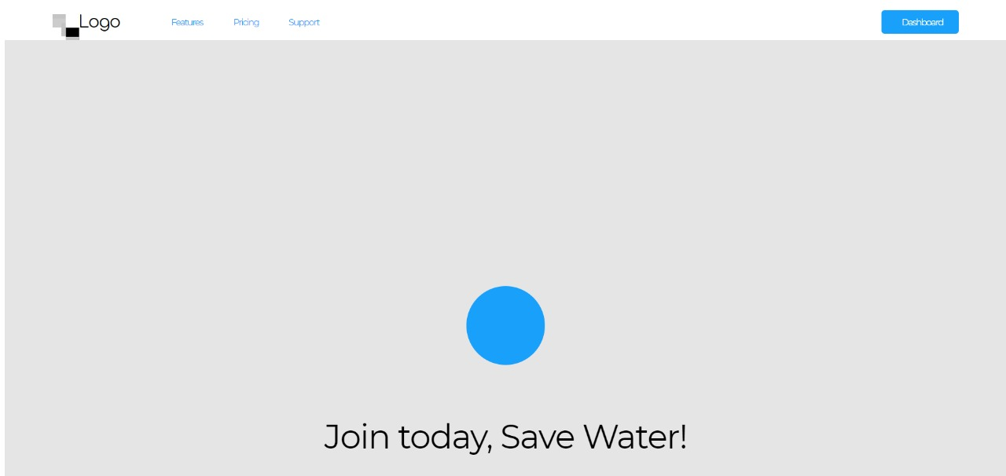

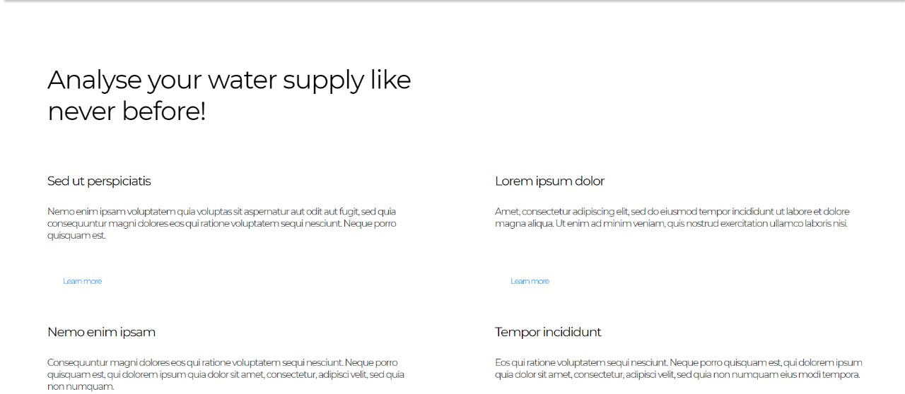

The landing page consists of photos, diagrams and texts showing people how our system works and how it can be used to increase crop yield and reduce water.

The images above are our wireframed page, which do not contain any information as of yet.

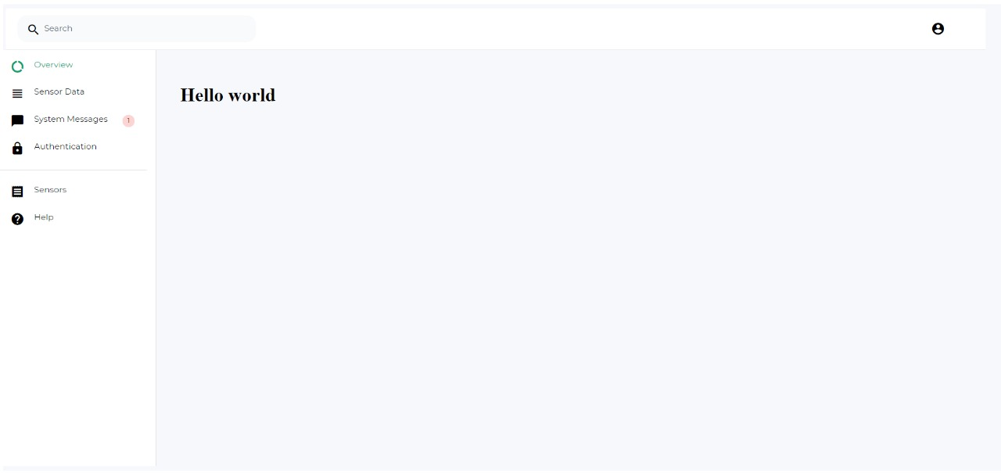

On logging in, the user will be greeted with this page which tabulates all the information provided by the sensors. Currently the table has not been implemented here but it can be seen in our User interfaces in prior sections.

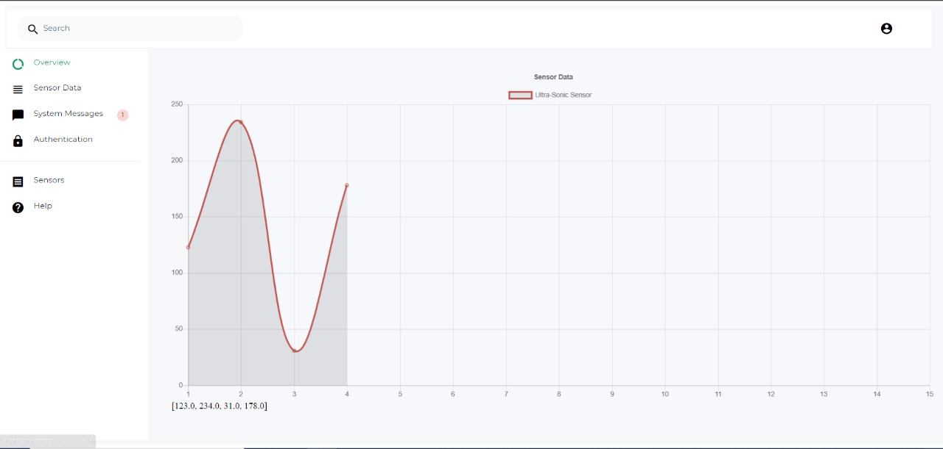

On selecting a specific sensor, the user will be met with a graph like this which plots the sensor data as a time series graph.